Converting classic activity guide process into Fluid

I have taken example of the delivered eBenefits life event activity guide. You can use this guide also if you are creating a new custom activity guide.

- Navigate to the activity guide setup page and setup the activity guide pages to fluid pages. Classic pages do not display correctly in fluid activity guide and fluid pages take up the whole page. Below is the life event pages delivered as classic. All of these need to be changed to fluid.

Note: When you create your own Activity guide, you will have to follow this same principal.
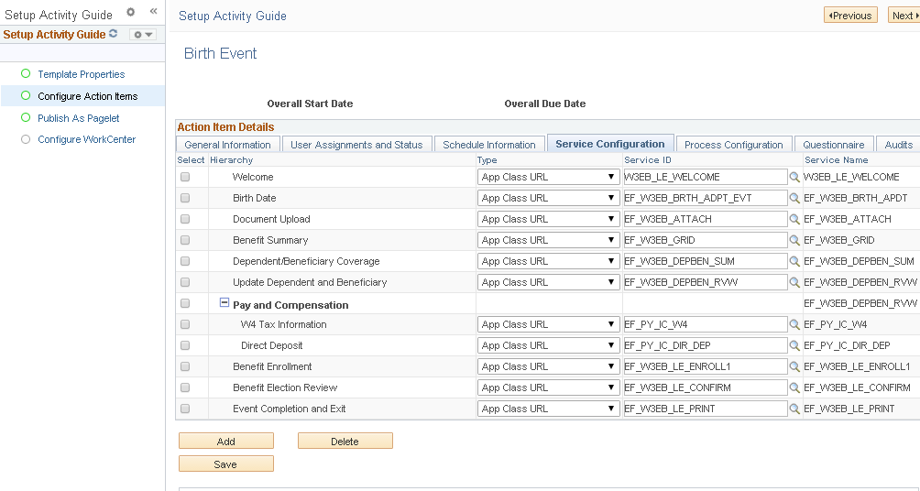

- Extremely Important - I updated the code on W3EB_LE_WRK.LE_START_EVENT.FieldChange and W3EB_SEL_EVNT_FLU.GBL.DERVIED_EB_FLU.LE_DATE_SUBMIT_PB.FieldChange, this is where the life event trigger the Activity guide. PT_AGSTARTPAGE_NUI is a delivered component that is used to display any activity guide. If you are creating a custom activity guide then make sure you are using the code below and then passing the correct template name and context parameters.

Rem &url = GenerateComponentPortalURL(%Portal, %Node, MenuName.W3EB_MENU, %Market, Component.W3EB_LE_WELCOME, Page.W3EB_LE_WELCOME, "U");

&url = GenerateComponentPortalURL(%Portal, %Node, MenuName. NUI_FRAMEWORK, %Market, Component.PT_AGSTARTPAGE_NUI, Page. PT_AGSTARTPAGE_NUI, "U");

&url = &url | "&" | "CONTEXTIDPARAMS=" | "TEMPLATE_ID" | ":" | &TEMPLATE_ID | "&" | "CONTEXTIDPARAMS=" | "OPRID" | ":" | &OPRID_VALUE | "&" | "CONTEXTIDPARAMS=" | "EMPLID" | ":" | &EMPLID_VALUE | "&replaceCurrentTopWindow=Y";

- Now your activity guide is changed to use fluid. Below is screenshot of the updated process

Navigate to fluid dashboard and click on benefit tile

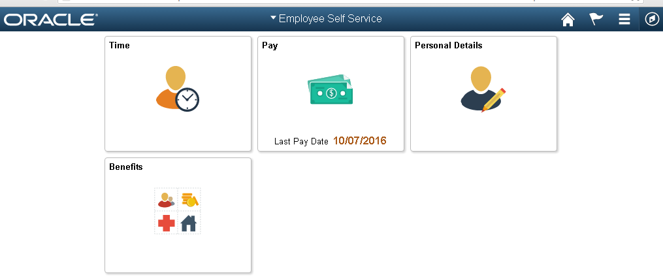

On the benefit tile click on life event menu on left. Select the life event and date.

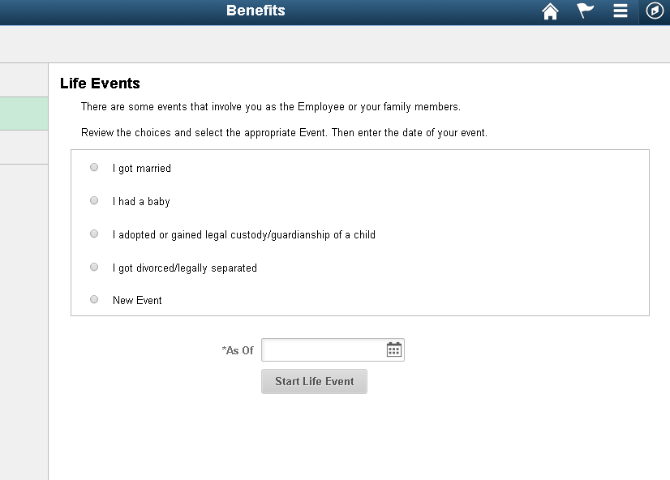
Before the change:

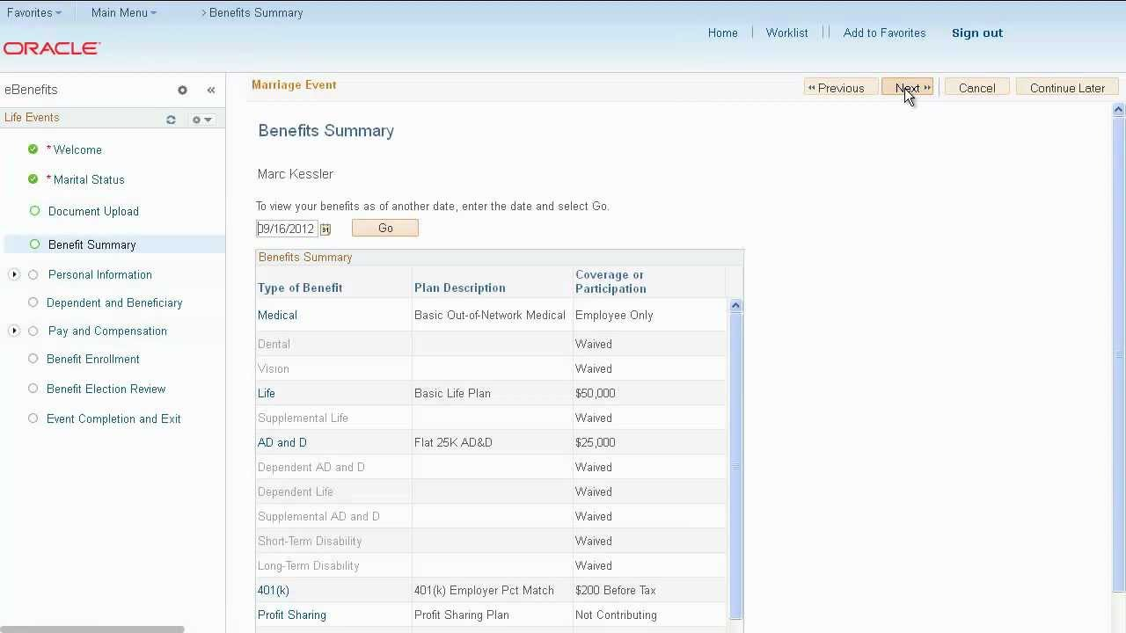

After the change: [Do not worry about the HTML text on the page. I did not convert welcome page to fluid and hence it is having issues pulling classic welcome page (talked about this at the start)]

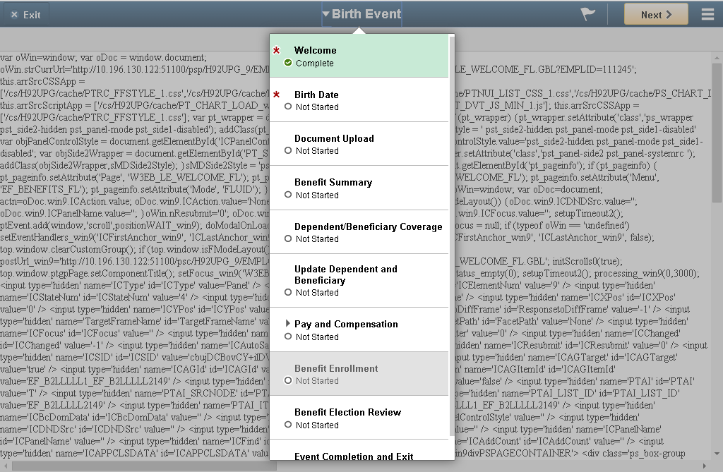

That’s it! Hope this provide you a good start.

